Evaluating the Performance of ANN-SVM Classifiers in Predicting Customer Response to a Marketing Campaign

Dr. Debrup Banerjee, Jenifa X, Nikita Sara M, Brendan Faleiro, Harshinidevi S, Kamal P, Sri Durga S

Abstract
Among machine learning approaches, Artificial Neural Network (ANN) models have become increasingly popular. One of the primary reasons for this growth is that ANNs do not require manually engineered features. This has contributed to their growing use in areas such as marketing analytics. The models employed in these studies vary considerably, providing opportunities to compare the performance of different models.

1. Introduction and Literature Survey:
With the Internet’s rapid growth and widespread accessibility, a company’s website has become a key component of its digital presence and has significantly influenced the way retailers market their products (Salehi, 2012). In the digital age, customer behaviour on websites and social media plays a vital role in influencing purchasing decisions. Activities such as clicks, likes, comments, and reviews provide measurable indicators of consumer engagement, and machine learning approaches have been used to predict specific forms of engagement, such as liking, commenting, or sharing, that customers are most likely to exhibit in response to marketing content (Yonghui Dai, 2021). Further, consumer behaviour also reflects the customers’ purchase intentions.
However, consumers do not respond to digital engagement in the same way. Their responses are influenced by demographic variables such as educational level and marital status. Machine learning procedures incorporating socio-demographic variables have been shown to improve predictive accuracy by 20 to 33 percent over standard logistic regression models (Towhidul Islam, 2022). This suggests that demographic characteristics can provide valuable information for understanding differences in consumer response and purchase behaviour.
Website characteristics and online behavioural information also play an important role in understanding consumer behaviour. Website information, along with features such as personalisation, play a key role in determining the e-commerce success of companies (Salehi, 2012). Data such as website visits have become increasingly significant as digital interactions continue to expand, while website interactivity has been shown to influence both visit frequency and purchase frequency (Hood, 2015). It has always been vital for retail companies to incorporate customer segmentation into their strategies in order to improve the effectiveness of targeting efforts. With the widespread adoption of digital technologies, traditional customer profiling can therefore be complemented by online behavioural data, allowing organizations to develop a more comprehensive understanding of their customers.
Behavioural intentions, coupled with an individual’s perception of behavioural control, help predict whether a person will engage in a particular behaviour. This relationship has been examined in studies investigating the links between online viral behaviours, engagement, and offline actions. Researchers have also noted the increasing importance of social media marketing for advertisers (Alhabash, 2015). Attitudes and motivations toward advertisements on social media significantly influence purchase intention, while word-of-mouth marketing has been associated with increased advertisement clicks (Erdem, 2017). These findings indicate that digital interactions can provide useful behavioural signals for understanding and predicting customer responses.
A growing body of literature has examined the relationship between customer engagement, website effectiveness, and purchase outcomes. For example, this relationship has been observed among customers who visit travel websites before making purchase decisions (Anubha, 2019). Retailers have therefore increasingly recognized the importance of predicting consumer purchase intent to improve conversion rates and profitability. Studies indicate that clickstream datasets can provide valuable insights into customer shopping preferences and purchase intent (Wen, 2023). Higher levels of website involvement by customers have also been associated with stronger purchase intentions, with research demonstrating a positive relationship between cognitive and affective involvement and purchase intention (Jiang, 2010). In addition, machine learning models that combine engagement measures with behavioural theory, including Support Vector Machines (SVM), have been used to predict purchase behaviour arising from social media engagement (Md Shawmoon Azad, 2023).
Consumer behaviour is also influenced by cultural and contextual factors. Advertising attitudes not only affect consumers’ willingness to seek information but also influence their purchase intentions. After clicking advertisements, consumers evaluate brands and products before deciding whether to proceed with a purchase. In addition to user clicks, longer browsing sessions have been associated with stronger purchase intentions. However, click behaviour alone may not be sufficient for predicting purchase intent. Therefore, behavioural data may need to be supplemented with demographic and other contextual information. Recent work has shown that combining customer characteristics, such as demographic and historical purchase data, with behavioural data on website browsing can substantially improve the prediction of purchase outcomes compared with using either type of information independently (Seongbeom Kim, 2024).
From a demographic perspective, Millennials and Generation Z have been described as more technologically oriented than older cohorts, making digital communications particularly relevant to their consumer behaviour (Charles, 2025). Demographic variables can also affect perceptions of social media advertisements, satisfaction with online shopping, and other factors influencing consumer decision-making (Kiruthika, 2025). Machine learning models have evolved significantly in recent years. By harnessing the capabilities of these models, researchers can gain deeper insights into engagement with social media advertisements and its relationship with purchase intention. Studies have also noted that Chinese social media platforms differ considerably from their Western counterparts, resulting in different consumer interaction patterns. Various forms of interaction, including consumer-streamer, consumer-platform, and consumer-consumer interactions, have been found to influence purchase intention through the mechanisms of social presence and trust (Zhang, 2024).
Among machine learning approaches, Artificial Neural Network (ANN) models have become increasingly popular (Mahmoud Kasem, 2024). ANNs are capable of learning complex and nonlinear relationships from data, and representation learning can reduce the reliance on manually designed feature representations in appropriate settings (Bengio, 2013). However, neural networks do not always perform better than other methods when working with structured or tabular data. Studies have shown that tree-based and other machine learning models can sometimes perform better than neural networks on such datasets (Leo Grinsztajn, 2022). Therefore, it is important to compare ANN models with established methods such as SVM rather than assuming that one method will perform better.
ANN models have also been used in marketing and campaign-response prediction (Koç, 2013). Their performance can vary depending on their architecture, particularly the number of hidden layers and neurons (K Gnana Sheela, 2013). Research in direct marketing has further shown that AI-based models can identify useful patterns in customer characteristics and behaviour (Mahmoud Kasem, 2024). Neural networks achieve this by using interconnected computational units and nonlinear transformations to learn relationships between input variables and outcomes (Greene, 2017).
SVMs have been widely used for customer response and purchase prediction, including direct marketing with imbalanced data (Rogić, 2022). Machine learning has also been successfully used to predict customer responses in telemarketing campaigns (Sérgio Moro, 2014). However, ANN and SVM have mostly been studied separately.
Hybrid ANN models have shown promising results in related tasks such as customer churn prediction (P Ramesh, 2022). However, limited research has examined different ANN architectures combined with SVM for marketing campaign response prediction. In particular, the effect of changing the number of hidden layers and neurons has received limited attention. This study addresses this gap by testing different ANN architectures with SVM and comparing their performance with a standalone SVM model.
Recent research shows that customer purchase prediction is a growing area of machine learning research (Shuixia Chen, 2024). Therefore, this study aims to determine whether different ANN architectures can improve the performance of an SVM model in predicting customer responses to a marketing campaign.

2. Methodology:
This study focuses on predicting customer responses to marketing campaigns by comparing the performance of Support Vector Machine (SVM) and Artificial Neural Network (ANN) models.
2.1 Data Collection
The Marketing Campaign dataset is a widely used simulated dataset. It was obtained from a masterclass and published on Kaggle by Rodolfo Saldanha in 2020 (username: rodsaldanha) under the title Marketing Campaign, making it openly accessible to the research community under a CC0 Public Domain license (Saldanha, 2020). The dataset simulates a direct marketing campaign conducted by a retail company involving 2,240 customers. It has also been used by the Brazilian online retail company iFood for recruiting Data Analysts for the iFood Brain team, where it was described as containing mock meta-information on customers and their interactions with iFood's marketing campaigns (npradaschnor, 2021).
The dataset has been utilized in several studies aimed at developing and evaluating models for marketing campaigns. Chongsen Ma, employed the dataset within a logistic regression framework to investigate profit-maximizing targeting strategies, identifying annual income and wine expenditure as the strongest predictors of campaign acceptance (Ma, 2025). El-Hajj and Pavlova used the dataset to develop a predictive model based on a Decision Tree (DT) algorithm (El-Hajj, 2024). Similarly, Diyabi et al. utilized the same dataset to conduct a systematic comparative evaluation of K-Means, DBSCAN, Gaussian Mixture Models (GMM), and Self-Organizing Maps (SOM) for retail customer segmentation.(Diyabi, 2025).
2.2 Exploratory Data Analysis
Property | Value
Total Records (Rows) | 2,240
Total Attributes (Columns) | 29
Target Variable | Response (Binary)
Missing Values | 24 (Income only)
Duplicate Records | 0
Table 1: Summarizes the basic structural properties of the dataset.

The target variable, Response, is notably imbalanced. Of the 2,240 customers in the dataset, only 334 (14.9%) accepted the campaign offer, while 1,906 (85.1%) declined. Such class imbalance is a common characteristic of marketing campaign dataset (Rogić, 2022).
This imbalance has important implications for model evaluation, as accuracy alone can be misleading. Therefore, additional performance metrics such as Precision, Recall, F1-score, and Cohen's Kappa are also considered when evaluating the models.
Response Class | Count | Percentage
0 – Did Not Respond | 1,906 | 85.1 %
1 – Responded | 334 | 14.9 %
Total | 2,240 | 100.0 %
Table 2: Dataset Dimensions
2.3 Variables:
Dependent Variable
Response (target) – 1 if customer accepted the offer in the last campaign, 0 otherwise.
Independent Variables
AcceptedCmp1 – 1 if customer accepted the offer in the 1st campaign, 0 otherwise
AcceptedCmp2 – 1 if customer accepted the offer in the 2nd campaign, 0 otherwise
AcceptedCmp3 – 1 if customer accepted the offer in the 3rd campaign, 0 otherwise
AcceptedCmp4 – 1 if customer accepted the offer in the 4th campaign, 0 otherwise
AcceptedCmp5 – 1 if customer accepted the offer in the 5th campaign, 0 otherwise
Complain – 1 if customer complained in the last 2 years
DtCustomer – date of customer’s enrolment with the company
Education – customer’s level of education
Marital – customer’s marital status
Kidhome – number of small children in customer’s household
Teenhome – number of teenagers in customer’s household
Income – customer’s yearly household income

MntFishProducts – amount spent on fish products in the last 2 years
MntMeatProducts – amount spent on meat products in the last 2 years
MntFruits – amount spent on fruit products in the last 2 years
MntSweetProducts – amount spent on sweet products in the last 2 years
MntWines – amount spent on wine products in the last 2 years
MntGoldProds – amount spent on gold products in the last 2 years
NumDealsPurchases – number of purchases made with discount
NumCatalogPurchases – number of purchases made using catalogue
NumStorePurchases – number of purchases made directly in stores
NumWebPurchases – number of purchases made through company’s website
NumWebVisitsMonth – number of visits to company’s website in the last month
Recency – number of days since the last purchase
Control Variables
Z_CostContact – cost to contact a customer
Z_Revenue – revenue earned after a client accepts the campaign

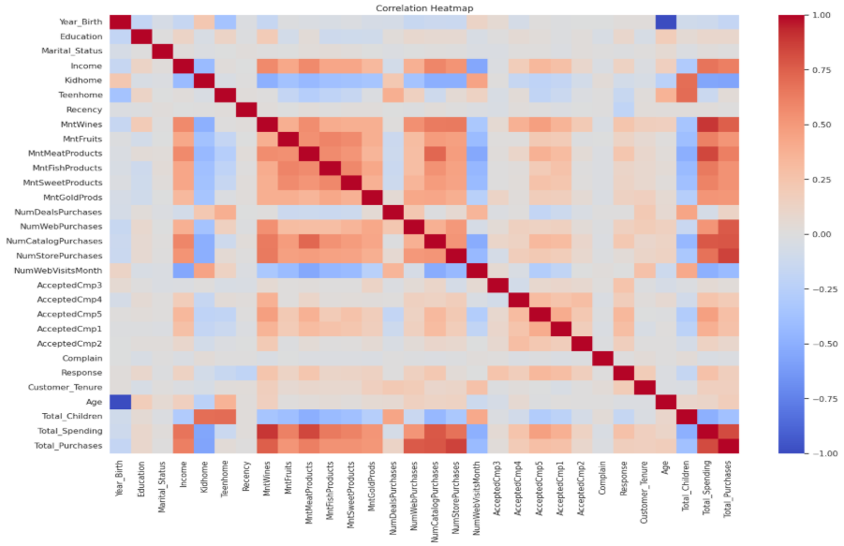
Fig 1: Correlation Heatmap representing correlation between various features in the dataset
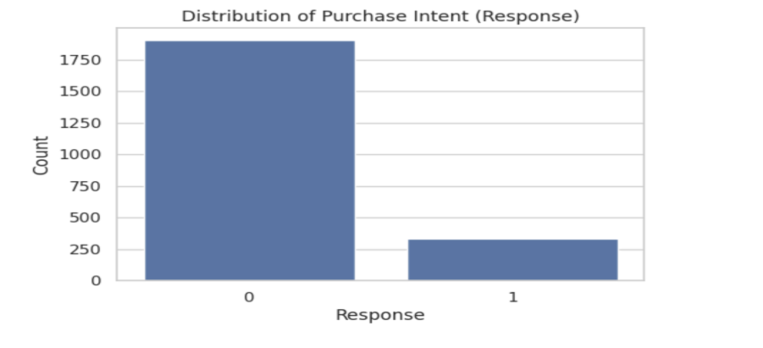
Fig 2: Bar chart representing data imbalance
2.4 Data Preparation
2.4.1 Data Cleaning
A review of the 2,240 records found no duplicate entries in the dataset (Table 1).
2.4.2 Missing Value Treatment
The dataset is largely complete, with missing values occurring only in the Income attribute. This variable contains 24 null entries, representing 1.07% of the 2,240 records. All other 28 attributes are fully populated.
Attribute | Missing Count | % Missing
Income | 24 | 1.07 %
All other attributes (28) | 0 | 0.00 %
Table 3: Missing Values
Statistical imputation using the median was preferred in order to account for outliers.
2.4.3 Outlier Handling
Three customers in the dataset were identified as being over 100 years of age. Given the biological improbability of such observations, these records were treated as outliers and removed from the dataset.
2.5 Model Specification: Baseline SVM and Proposed ANN-SVM Models
2.5.1 Baseline Model: Support Vector Machine (SVM)
Support Vector Machine (SVM) was used as the baseline model. It was selected because it is a well-established and reliable classifier for binary prediction problems such as customer response prediction. SVM works by finding an optimal decision boundary, or hyperplane, that separates customers who responded to a marketing campaign from those who did not. The shape of this boundary depends on the kernel function used.
To evaluate the performance of SVM, three kernel functions were tested: Linear, Radial Basis Function (RBF), and Exponential. For each kernel, the model was trained and tested using three train-test split ratios: 70:30, 80:20, and 90:10. This resulted in a total of nine configurations (3 kernels × 3 split ratios). Testing multiple split ratios helped identify the configuration that produced the most reliable results.
Each configuration was evaluated using five performance metrics: Accuracy, Precision, Recall, F1-score, and Cohen's Kappa. The average of these metrics was used to compare the configurations. The best-performing SVM configuration was then selected as the baseline model for further comparison.
2.5.2 Proposed Model: Artificial Neural Network for Feature Extraction
Artificial Neural Networks (ANNs) for feature extraction coupled with SVM as the classifier were developed as the proposed model to determine whether a more complex learning approach could improve prediction performance compared to the SVM baseline.
The ANN models were trained and tested using the same dataset as the SVM model. However, only the 80:20 train-test split was used, as this split produced the best results during the SVM experiments.
To examine the effect of network complexity on performance, five ANN architectures were developed.
Architecture | Hidden Layers | Neurons per Layer
1 | 2 | 100 – 50
2 | 2 | 500 – 100
3 | 3 | 1000 – 500 – 50
4 | 3 | 2000 – 1000 – 100
5 | 3 | 2000 – 1000 – 50
Table 4: ANN Architectures used
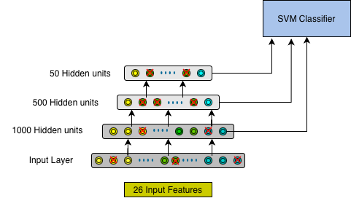
Fig 3: Methodology used for proposed model

These architectures were designed to evaluate whether increasing the number of neurons and hidden layers improves the model's ability to capture complex, non-linear relationships between customer characteristics and campaign response. While larger networks have greater learning capacity, they may also increase the risk of overfitting. Comparing these architectures helps determine whether the additional complexity leads to better predictive performance. The feature representations learned by the ANN architectures are expected to capture complex non-linear relationships within the data. To classify these learned features, non-linear SVM classifiers using RBF and Exponential kernels were applied to the outputs of all five ANN architectures. In order to determine the number of training epochs at which all the models converge, 20% of the training set was used as a validation set with accuracy as the metric. After which, the models were trained and tested using the 80:20 train-test split on the same number of epochs.
Similar to the baseline SVM model, each ANN-SVM configuration was evaluated using Accuracy, Precision, Recall, F1-score, and Cohen's Kappa. The average of these metrics was used to compare the performance of the different configurations.
2.5.3 Evaluation Metrics
To allow fair comparison across all models, five evaluation metrics were used: Accuracy, Precision, Recall, F1-score, and Cohen's Kappa. These metrics are based on the outcomes of binary classification: True Positives (TP), True Negatives (TN), False Positives (FP), and False Negatives (FN).
- Accuracy measures the proportion of correctly classified observations:
Accuracy = (TP + TN) / (TP + TN + FP + FN)
- Precision measures the proportion of predicted positive cases that are actually positive:
Precision = TP / (TP + FP)
- Recall measures the proportion of actual positive cases correctly identified:
Recall = TP / (TP + FN)
- F1-score is the harmonic mean of Precision and Recall:
F1-score = 2 × (Precision × Recall) / (Precision + Recall)
- Cohen’s Kappa measures agreement between predicted and actual classifications while accounting for chance agreement:
- Kappa = (p₀ − pₑ) / (1 − pₑ)
where p₀ is the observed agreement and pₑ is the agreement expected by chance.
2.5.4 Hypothesis Testing
The F1-score was selected as the primary metric for statistical comparison because it balances Precision and Recall and is particularly suitable for classification problems with class imbalance.
To evaluate whether the best-performing ANN-SVM model significantly outperformed the baseline SVM model, repeated stratified 5-fold cross-validation was employed. The dataset was divided into five folds, and the cross-validation procedure was repeated twice. This resulted in 10 F1-score observations for the baseline SVM model and 10 F1-score observations for the best-performing ANN-SVM model, giving a total of 20 F1-score observations for statistical analysis.
Since the F1-score samples obtained from cross-validation may not satisfy the normality assumption required for parametric tests and the sample size was relatively small, the Wilcoxon Signed-Rank Test was used to compare the performance of the two models. The Wilcoxon Signed-Rank Test is used to compare two paired or related samples when the data may not follow a normal distribution. It determines whether there is a statistically significant difference between the median values of the paired observations.
The hypotheses tested were:
Null Hypothesis (H₀):
There is no significant difference in the median F1-score between the baseline SVM model and the best-performing ANN-SVM model.
Alternative Hypothesis (H₁):
The median F1-score of the best-performing ANN-SVM model is significantly greater than that of the baseline SVM model.
The test was conducted at a significance level of α = 0.05. If the p-value was less than 0.05, the null hypothesis was rejected, indicating that the ANN-SVM model achieved a statistically significant improvement in predictive performance compared to the baseline SVM model.

2.5.5 Software Used: MS Excel, Python , Google Colab, Lightning AI Notebook.

3. Results
Compiled Metrics Table for All 3 SVM Models (80:20)
No. | Model | Accuracy | Recall | F1-Score | Precision | ROC-AUC | Kappa Score | Average
1 | Linear SVM | 0.8929 | 0.3433 | 0.4894 | 0.8519 | 0.8591 | 0.4414 | 0.6037
2 | Exponential Kernel SVM | 0.8772 | 0.2388 | 0.3678 | 0.8 | 0.8625 | 0.3211 | 0.5209
3 | RBF Kernel SVM | 0.8728 | 0.2388 | 0.3596 | 0.7273 | 0.8781 | 0.3084 | 0.5013

Compiled Metrics Table for All 3 SVM Models (70:30)
No. | Model | Accuracy | Precision | Recall | F1-Score | ROC-AUC | Kappa Score | Average
1 | Linear SVM | 0.8854 | 0.7556 | 0.3400 | 0.469 | 0.8638 | 0.4149 | 0.57298
2 | Exponential Kernel SVM | 0.8765 | 0.8148 | 0.22 | 0.3465 | 0.8637 | 0.3023 | 0.51202
3 | RBF Kernel SVM | 0.8824 | 0.7838 | 0.2900 | 0.4234 | 0.8671 | 0.373 | 0.55052

Compiled Metrics Table for All 3 SVM Models (90:10)
 | Model | Accuracy | Precision | Recall | F1-Score | ROC-AUC | Kappa Score | Average
1 | Linear SVM | 0.8795 | 0.7143 | 0.303 | 0.4255 | 0.8255 | 0.3703 | 0.53852
2 | Exponential Kernel SVM | 0.875 | 0.8571 | 0.1818 | 0.3 | 0.8374 | 0.2619 | 0.49516
3 | RBF Kernel SVM | 0.8705 | 0.7000 | 0.2121 | 0.3256 | 0.8701 | 0.2760 | 0.4694

Model Convergence Graph

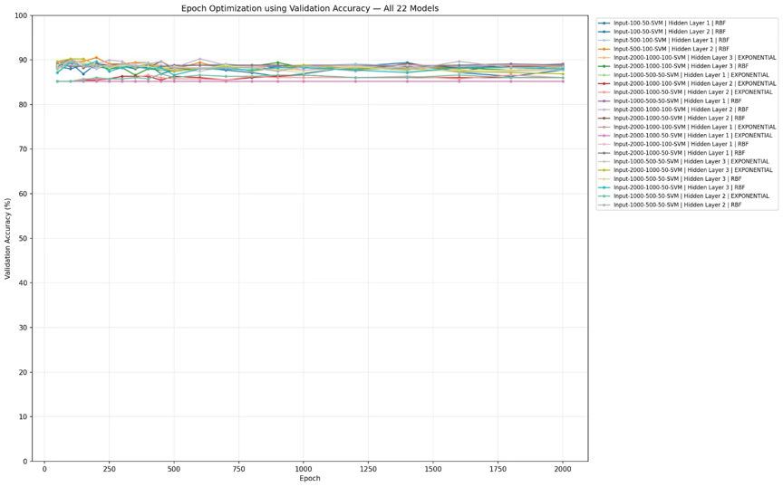
The validation set results showed that the models converged at 2000 epochs, so each model was trained for the full 2000 epochs before its final, one-time evaluation on the test set.

ANN (2 Hidden Layers) EPOCH = 2000
ANN Architecture | Hidden Layer for Classification | Accuracy | Precision | Recall | F1 Score | ROC -AUC | Kappa Score | Average
Input-100-50-SVM | 1 | 0.8705 | 0.6452 | 0.2985 | 0.4082 | 0.8802 | 0.3463 | 0.51374
Input-100-50-SVM | 2 | 0.8661 | 0.5660 | 0.4478 | 0.5000 | 0.8391 | 0.4239 | 0.56076
Input-500-100-SVM | 1 | 0.8750 | 0.6897 | 0.2985 | 0.4167 | 0.8852 | 0.3587 | 0.52772
Input-500-100-SVM | 2 | 0.8839 | 0.6596 | 0.4627 | 0.5439 | 0.8224 | 0.4797 | 0.60596

ANN (3 Hidden Layers) EPOCH = 2000
ANN Architecture | Hidden Layer for Classification | Kernel | Accuracy | Precision | Recall | F1 Score | ROC -AUC | Kappa Score | Average
Input-1000-500-50-SVM | 1 | RBF | 0.8795 | 0.7097 | 0.3284 | 0.449 | 0.8929 | 0.3914 | 0.5516
Input-1000-500-50-SVM | 2 | RBF | 0.8772 | 0.625 | 0.4478 | 0.5217 | 0.8733 | 0.4535 | 0.5850
Input-1000-500-50-SVM | 3 | RBF | 0.8795 | 0.6383 | 0.4478 | 0.5263 | 0.73 | 0.4597 | 0.5903
Input-2000-1000-100-SVM | 1 | RBF | 0.8772 | 0.7143 | 0.2985 | 0.4211 | 0.8938 | 0.3651 | 0.5352
Input-2000-1000-100-SVM | 2 | RBF | 0.8750 | 0.6122 | 0.4478 | 0.5172 | 0.8733 | 0.4474 | 0.5799
Input-2000-1000-100-SVM | 3 | RBF | 0.8862 | 0.6818 | 0.4478 | 0.5405 | 0.7147 | 0.4787 | 0.607
Input-2000-1000-50-SVM | 1 | RBF | 0.8750 | 0.6897 | 0.2985 | 0.4167 | 0.8869 | 0.3587 | 0.5277
Input-2000-1000-50-SVM | 2 | RBF | 0.8839 | 0.6596 | 0.4627 | 0.5439 | 0.8781 | 0.4797 | 0.605
Input-2000-1000-50-SVM | 3 | RBF | 0.8862 | 0.6905 | 0.4328 | 0.5321 | 0.7201 | 0.4712 | 0.602
Input-1000-500-50-SVM | 1 | Exponential | 0.8549 | 1 | 0.0299 | 0.0580 | 0.8804 | 0.0497 | 0.3985
Input-1000-500-50-SVM | 2 | Exponential | 0.8728 | 0.8125 | 0.194 | 0.3133 | 0.8828 | 0.2712 | 0.4927
Input-1000-500-50-SVM | 3 | Exponential | 0.8839 | 0.6596 | 0.4627 | 0.5439 | 0.8771 | 0.4797 | 0.618
Input-2000-1000-100-SVM | 1 | Exponential | 0.8527 | 1 | 0.0149 | 0.0294 | 0.8795 | 0.0251 | 0.384
Input-2000-1000-100-SVM | 2 | Exponential | 0.8772 | 0.875 | 0.209 | 0.3373 | 0.8824 | 0.2968 | 0.5210
Input-2000-1000-100-SVM | 3 | Exponential | 0.8549 | 0.5238 | 0.3284 | 0.4037 | 0.6608 | 0.3260 | 0.4216
Input-2000-1000-50-SVM | 1 | Exponential | 0.8795 | 0.8095 | 0.2537 | 0.3864 | 0.8683 | 0.3392 | 0.53366
Input-2000-1000-50-SVM | 2 | Exponential | 0.8862 | 0.6600 | 0.4925 | 0.5641 | 0.8759 | 0.5002 | 0.6206
Input-2000-1000-50-SVM | 3 | Exponential | 0.8817 | 0.6591 | 0.4328 | 0.5225 | 0.7342 | 0.4583 | 0.5908

Hypothesis Results
Fold | Baseline F1 | Proposed F1 | Improvement
1 | 0.5200 | 0.6102 | +0.0902
2 | 0.4545 | 0.5440 | +0.0895
3 | 0.4854 | 0.6015 | +0.1161
4 | 0.4848 | 0.5039 | +0.0191
5 | 0.4894 | 0.5091 | +0.0197
6 | 0.4800 | 0.5333 | +0.0533
7 | 0.5739 | 0.5496 | −0.0243
8 | 0.5051 | 0.6457 | +0.1406
9 | 0.4898 | 0.5246 | +0.0348
10 | 0.4167 | 0.5310 | +0.1143
Mean | 0.4900 | 0.5553 | +0.0653
Std. Dev. | 0.0387 | 0.0450 | —

Final Results:
Baseline Mean F1 (Linear SVM): 0.48996186682882625
Baseline Std: 0.03866589417473004
Proposed Mean F1: 0.5552885728433308
Proposed Std: 0.045014302131045306

Wilcoxon Statistic: 52.0
- value: 0.0048828125
Significance level alpha = 0.05

Since 0.00488 < 0.05: Reject H0 and accept H1.

The Wilcoxon Signed-Rank Test indicated that the proposed ANN-SVM model (Input-2000-1000-50, Exponential kernel SVM) significantly outperformed the baseline Linear SVM model in terms of F1-score across 10 matched cross-validation folds (W = 52.0, p = 0.00488 < 0.05). Therefore, the null hypothesis was rejected, and the alternative hypothesis was accepted.

4. Discussion:
Linear SVM was found to be the best performing SVM model with robust results, making it the ideal baseline and validating its popularity within the industry.

The best performing ANN architecture had hidden layers as 2000-1000-50 and exponential kernel in the SVM classifier while features from the second hidden layer were fed into the SVM classifier. In general, architectures with a lesser number of neurons in the final hidden layer performed better. This may be due to the smaller number of neurons in the final hidden layer naturally acting as a bottleneck, forcing the network to compress raw, high-dimensional information into highly condensed, meaningful representations before passing it to the output layer.

The results from the Wilcoxon Signed-Rank Test show that proposed model outperformed the baseline. The implications of this result are significant. It shows that ANN models can capture complex non- linear connections within the attributes of a marketing campaign dataset and predict the response successfully.

Given that the proposed model produced significantly better f1 scores then the baseline model, it indicates that the proposed model is superior at predicting the minority class making it very relevant for marketing campaigns.

Future researchers can build upon this research by further experimentation with different architectures and different campaign features. A different classifier can be taken as the baseline. Given the computational limitations of this study, researchers with more computational resources can run experiments by increasing the architecture complexity, number of epochs etc.

4. Conclusion:
The proposed ANN-SVM model delivered better results than the baseline model.
This entails that Campaign Managers can confidently deploy ANN models to capture non-linear patterns within the features of their dataset using SVM as the classifier in order to increase the success of their Marketing Campaigns. We also observed that different architectures can yield a significant difference in results depending on the number of hidden layers used.

References
- Alhabash, S. M. (2015). From Clicks to Behaviors: The Mediating Effect of Intentions to Like, Share, and Comment on the Relationship Between Message Evaluations and Offline Behavioral Intentions. Journal of Interactive Advertising.
- Anubha, A. J. (2019). Consumer Engagement Towards Travel Websites and Purchase Intentions. Journal of Advanced Research in Dynamical and Control Systems, 11(08):2788-2794.
- Bengio, Y. C. (2013). Representation learning: A review and new perspectives. IEEE Transactions on Pattern Analysis and Machine Intelligence, 35(8), 1798–1828.
- Charles, J. &.(2025). The role of brand awareness and trust on purchase intent in Google shopping ads and demographic factor influences among Millennials and Generation Z. In Information Management and Technology (pp. 174–195). BP International.
- Diyabi, N. Ç. (2025). Evaluating customer segmentation techniques in the retail sector. International Journal of Interactive Multimedia and Artificial Intelligence, 9(3), 175–190.
- El-Hajj, M. &. (2024). Predictive modeling of customer response to marketing campaigns. Electronics, 13(19), Article 3953.
- Erdem, Ş. D. (2017). The Relationship with Ad Clicks and Purchase Intention: An Empiricial Study of Online Consumer Behaviour. European Journal of Economics and Business Studies, 9(1):25.
- Greene, M. N. (2017). Neural networks and consumer behavior: Neural models, logistic regression, and the Behavioral Perspective Model. The Behavior Analyst, 40(2), 393–418.
- Hood, K. M. (2015). The Influence of Interactivity on Visit and Purchase Frequency: The Moderating Role of Website Informational Features. Journal of Internet Commerce, 14(3), 294–315.
- Jiang, Z. C. (2010). Effects of Website Interactivity on Consumer Involvement and Purchase Intention. Journal of the Association for Information Systems.
- K Gnana Sheela, S. N. (2013). Review on methods to fix number of hidden neurons in neural networks. . Mathematical Problems in Engineering.
- Kiruthika, N. &. (2025). Beyond the Buy Button: Demographics Influence on Consumer Behavior in India’s Online Shopping. South India Journal of Social Sciences, 23(5):21-24.
- Koç, A. A. (2013). A comparative study of artificial neural networks and logistic regression for classification of marketing campaign results. Mathematical and Computational Applications, 18(3), 392–398.
- Leo Grinsztajn, E. O. (2022). Why do tree-based models still outperform deep learning on tabular data? Advances in Neural Information Processing Systems.
- Ma, C. (2025). Data-Driven Profit Maximization in Marketing Campaign: A Logistic Regression Approach. ICIBE '24: Proceedings of the 10th International Conference on Industrial and Business Engineering, Pages 41 - 45.
- Mahmoud Kasem, M. H.-E. (2024). Customer profiling, segmentation, and sales prediction using AI in direct marketing. Neural Computing and Applications.
- Md Shawmoon Azad, S. S. (2023). Predictive modeling of consumer purchase behavior on social media: Integrating theory of planned behavior and machine learning for actionable insights. PLoS One.
- npradaschnor. (2021). ifood_Case. GitHub, https://github.com/npradaschnor/ifood_Case.
- P Ramesh, J. E. (2022). Hybrid Artificial Neural Networks Using Customer Churn Prediction. Wireless Personal Communications.
- Rogić, S. K. (2022). Customer response model in direct marketing: Solving the problem of unbalanced dataset with a balanced support vector machine. Journal of Theoretical and Applied Electronic Commerce Research,, 17(3), 1003–1018.
- Saldanha, R. (2020). Marketing Campaign. Kaggle, https://www.kaggle.com/datasets/rodsaldanha/arketing-campaign.
- Salehi, F. A. (2012). The Impact of Website Information Convenience on E-commerce Success of Companies. Procedia - Social and Behavioral Sciences, 381-387.
- Seongbeom Kim, W. S.-W. (2024). Predicting online customer purchase: The integration of customer characteristics and browsing patterns. Decision Support Systems.
- Sérgio Moro, P. C. (2014). A data-driven approach to predict the success of bank telemarketing. Decision Support Systems.
- Shuixia Chen, Z. X. (2024). Customer purchase prediction in B2C e-business: A systematic review and future research agenda. Expert Systems with Applications .
- Towhidul Islam, N. M. (2022). The usefulness of socio-demographic variables in predicting purchase decisions: Evidence from machine learning procedures. Journal of Business Research.
- Wen, Z. L. (2023). Machine-Learning-Based Approach for Anonymous Online Customer Purchase Intentions Using Clickstream Data. Systems, 11(5):255.
- Yonghui Dai, T. W. (2021). Prediction of customer engagement behaviour response to marketing posts based on machine learning. Connection Science, 33(4), 891–910.
- Zhang, L. L. (2024). Impacts of different interactive elements on consumers' purchase intention in live streaming e-commerce. PLoS One.

